Set up

SQL Software used: SQL Server 2014 Management Studio

This application uses a local database.
First you need you create it.

In SQL Server 2014 Management Studio
In Object Explorer find the Database Folder.
Right Click and choose New Database

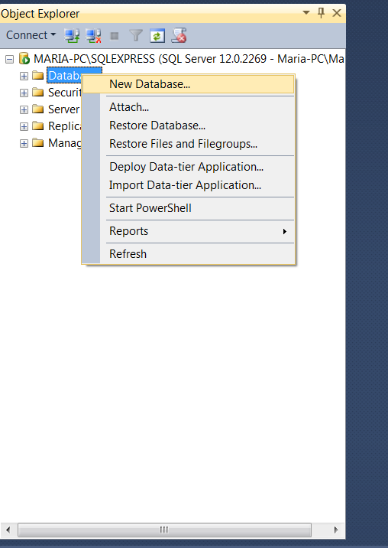

Choose a name for the Database (In my case it's EventManagementDb).

Then choose New Query

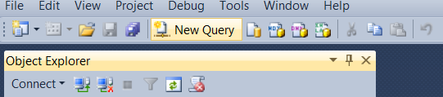
Make sure it is the query is for the database you created.(In my case it's EventManagementDb.)

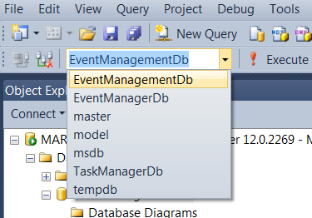

In the query window type in (or copy) the following text:

CREATE TABLE Events(
Id int NOT NULL IDENTITY(1,1),
Name varchar(30),
Location varchar(30),
StartDate datetime,
EndDate datetime,
PRIMARY KEY (Id)
);

(There is no need to save the query.)
Refresh the Folder Tables in your newly created database.

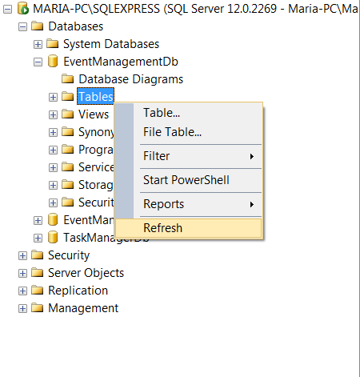

Expand the folder.
You should see your new table Events.
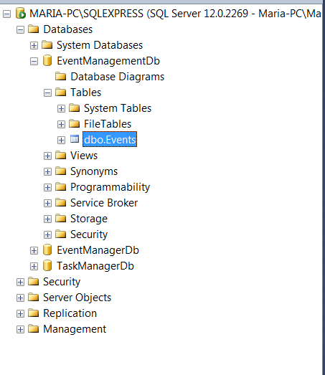
Open the folder EventManagerWeb.

Open EventManagerWeb.sln.

In the file menu click on Tools than on Connect to Database.

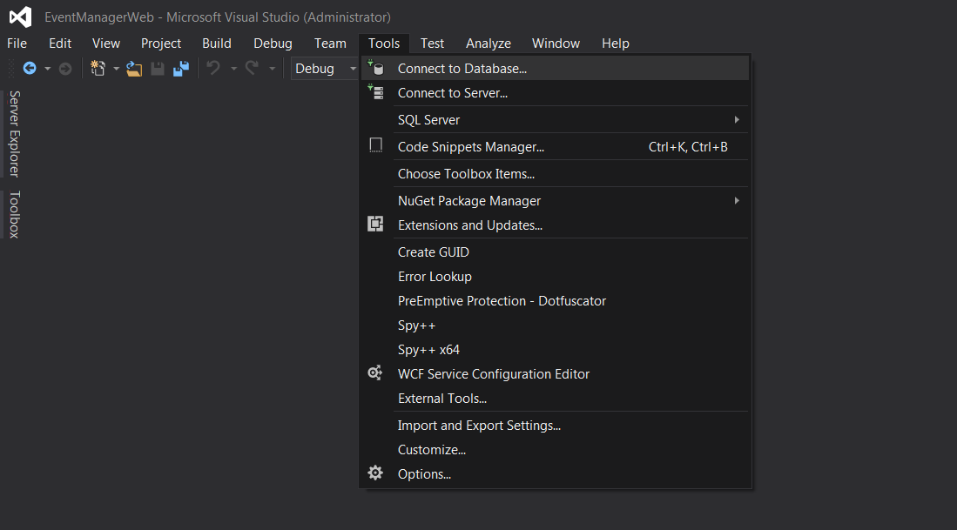

A window called Add Connection pops out.
You need to set the Server name to be the same as the name of your server in SQL Server 2014 Management Studio.

You can see the name of your server by right clicking on the first thing in the object explorer view and choosing Connect in SQL Server 2014 Management Studio :

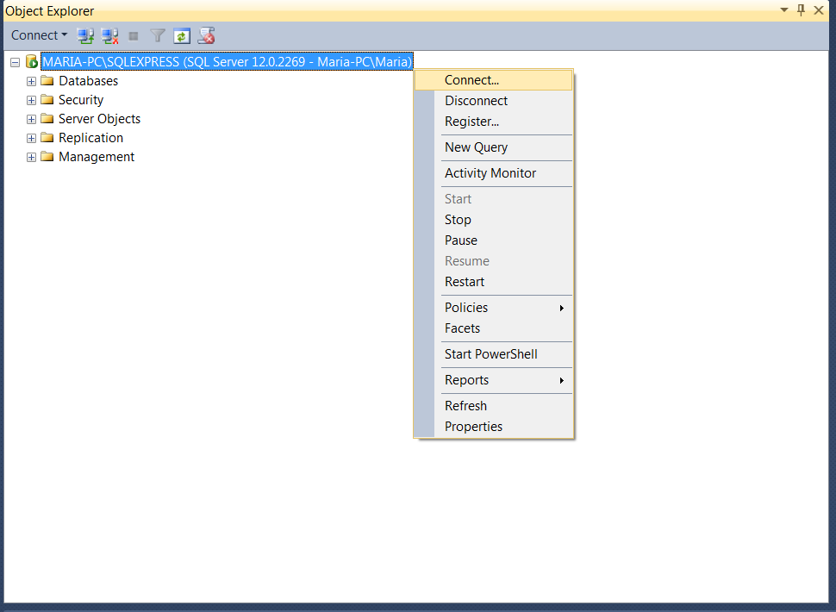

Then this will come up:

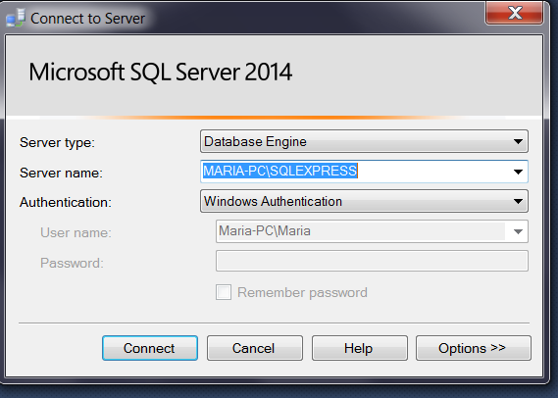

Copy the name, than Paste.

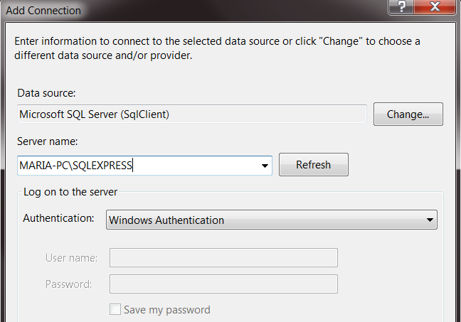

Then from the drop down "Select a Database" name menu in the Add Connection window, you can select your Database

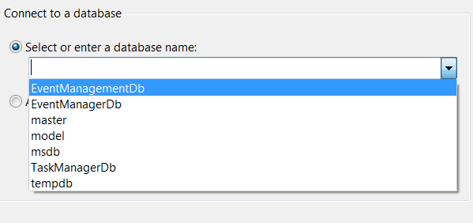.

And click OK.

In the Web.config file of the Web application, you need to find the following script:

<connectionStrings>
<add connectionString="Data Source=.\SQLEXPRESS; Initial Catalog=EventManagementDb; Integrated Security=true" name="EventManagerConnectionString"/>
</connectionStrings>

It's the first thing after the configuration tag.
If you chose a different name for your database, where the table Events is you would want to change EventManagementDb in Initial Catalog=EventManagementDb; to the name of your database.

You can also change the name of the connectionString in name="EventManagerConnectionString", but than you would need to also change it in the RepositoryFactory file, which is Folder Repositories in the console application Eventmanagament.

